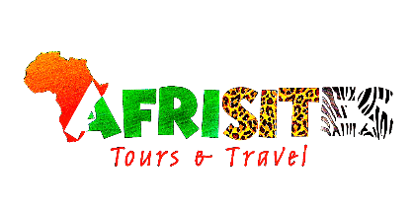

4-Day Gorillas and Chimpanzees Trekking Safari in Uganda

Overview

The top highlight of this 4-day Uganda gorilla safari is, of course, African mountain gorilla trekking in Uganda’s Bwindi Impenetrable Forest. The Uganda gorilla trek takes us through the dense jungle to encounter the endangered mountain gorillas in the wild. Bwindi Forest is also known for its high biodiversity and excellent bird watching. This tour also takes you to Kibale National Park for the chimpanzees trekking and finally enjoy the stunning views of Lake Bunyonyi.

Route
Start & End Day 1Day 2Day 3
Uganda
Start | Entebbe (Day 1)
Day 1 | Kibale NP (Chimps)
Day 2 | Bwindi Impenetrable NP (Gorillas)
Day 3 | Lake Bunyonyi
End | Entebbe (City) (Day 4)

Tour Features

Mid-range tour
This mid-range tour uses lodges and hotels.

Private tour
This tour will be organized exclusively for you and won't be shared with others.

Can start any day
If availability permits, this tour can start on any day.

Can be customized
You can request minor changes to the accommodations and destinations of this tour.

Suitable for solo travelers
Solo travelers can book this private tour.

Minimum age of 15 years
The minimum age for this tour is 15 years.

Activities & Transportation
- Activities: gorilla trekking & chimpanzee trekking
- Getting around: open-sided 4x4 vehicle & pop-up roof 4x4 vehicle
- A transfer from and back to the airport is included

Accommodation & Meals
- Additional accommodation before and at the end of the tour can be arranged for an extra cost
- Day Accommodation Meals
- Rweteera Safari Park Budget lodge just outside Kibale NP (Chimps)
Lunch & Dinner Included
- Rushaga Gorilla Lodge Mid-range lodge just outside Rushaga (Bwindi Impenetrable NP)
All Meals Included
- Itambira Island Mid-range hotel at Lake Bunyonyi
All Meals Included
- End of tour
(No accommodation)
Breakfast & Lunch Included

Day by Day

Arrival

You'll be collected from the airport.
- Accommodation before the tour starts can be arranged for an extra cost.

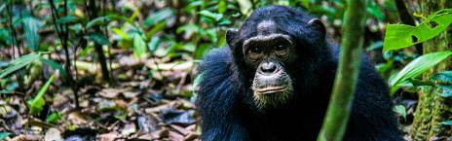

Day 1

Transfer to Kibale Forest National Park
Leaving Kampala, we'll drive through the dense jungles and papyrus wetlands of the Nile Delta. We'll pause for lunch en route to the Kibale National Park, near the towering Rwenzori Mountains, known as the 'Mountains of the Moon'. In the afternoon, we'll embark on a guided walk in the national park, exploring the crater lakes area and experiencing the local culture.
Main Destination:
Kibale National Park (Chimps)
Best Time to Visit January to February and June to July (Chimp trekking is easiest)
High Season June to September (Peak time for Uganda)
Best Weather January to February and June to July (Least rain)

Accommodation:
Rweteera Safari Park
- Budget lodge located just outside Kibale NP (Chimps)

Meals & Drinks:
- Lunch & dinner (Breakfast not included)
- Drinking water (Other drinks not included)

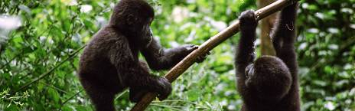

Day 2

Chimpanzee Trekking and Transfer to Bwindi Impenetrable National Park
Our day starts early, with breakfast and then chimpanzee tracking. The park is home to an impressive 500 chimpanzees. Before heading into the forest, we are briefed on the trekking procedures. While trekking in the jungle, the guide tells you more about the chimpanzees, other primates, and local flora and fauna, making for an interesting adventure.
The dense jungles of Kibale are the best place to view chimpanzees in Africa. The chimpanzees are commonly found feeding on fig tree fruits in the game park and have been habituated to humans since 1992. Kibale National Park covers 795sq km and consists mostly of a vast tract of equatorial rainforest. This national park is home to numerous forest wildlife species, boasting one of the highest concentrations of primates in the world. In the afternoon, we'll travel south to the Queen Elizabeth National Park, taking in the sights and looking out for the resident game as we drive. This evening, we'll relax and have dinner near Bwindi.
Main Destination:
Bwindi Impenetrable National Park (Gorillas)
Best Time To Visit June to August and December to February (Gorilla trekking is easiest)
High Season June to September (Gorilla permits are scarce)
Best Weather June to July and December to February (Less rainfall)

Accommodation:
Rushaga Gorilla Lodge
- Mid-range lodge located just outside Rushaga (Bwindi Impenetrable NP)

Meals & Drinks:
- All meals included
- Drinking water (Other drinks not included)

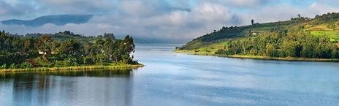

Day 3

Gorilla Trekking and Transfer to Lake Bunyonyi
Have an early morning breakfast and proceed to the briefing point. Enjoy the highlight of your trip, gorilla trekking, which may last from 2 to 6 hours depending on the group you are visiting. We'll trek through the rainforest and bamboo-covered slopes, accompanied by a Uganda Wildlife Authority guide and other trackers, in search of a mountain gorilla family. The walking can sometimes be tough and long, but when you catch a glimpse of the magnificent silverback, any discomforts will be quickly forgotten. Due to the nature of the activity, you will have a packed lunch. After gorilla trekking, you will drive through the terraced hills to Lake Bunyonyi. Besides canoeing, there is a short list of optional activities: swimming (safe in this lake), hiking on some of the Island trails along the lake shores, community walks and having a chance to meet the local people with small residents and exotic bird species singing.
Main Destination:
Lake Bunyonyi
Accommodation:
Itambira Island
- Mid-range hotel located at Lake Bunyonyi

Meals & Drinks:
- All meals included
- Drinking water (Other drinks not included)

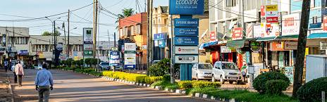

Day 4

Canoe Ride on Lake Bunyonyi And Transfer to Entebbe
After breakfast, check out of the lodge and transfer to Lake Bunyonyi for a guided canoe ride. You will later get set for a return journey back to Kampala and connect to Entebbe, Lunch will be served en route, arriving late in the evening to be dropped off at your hotel or airport as you say farewell to the Pearl of Africa.
Main Destination:
Entebbe (City)
Accommodation:
No accommodation (End of tour)
Meals & Drinks:
- Breakfast & lunch (Dinner not included)
- Drinking water (Other drinks not included)

End of tour
- Additional accommodation can be arranged for an extra cost.
- You'll be dropped off at the airport.

Rates

Important to Know
- Rates are per person and exclude the international flight from/to your home country.
- This tour accepts children who are 15 years and older. Children under 18 receive a discount.

Rates Per Person
Start dates | Solo1 room | 2 people1 room | 3 people2 rooms | 4 people2 rooms | 5 people3 rooms | 6 people3 rooms
Jan 1, 2026 - Dec 31, 2026 | $2,145 | $1,705 | $1,672 | $1,639 | $1,595 | $1,540

Inclusions

Included
- Park fees (For non-residents)
- Gorilla permits (One per person, non-resident)
- Chimp permits (One per person, non-resident)
- All activities (Unless labelled as optional)
- All accommodation (Unless listed as upgrade)
- A professional driver/guide
- All transportation (Unless labelled as optional)
- All Taxes/VAT
- Roundtrip airport transfer
- Meals (As specified in the day-by-day section)
- Drinking water (On all days)

Excluded
- International flights (From/to home)
- Additional accommodation before and at the end of the tour
- Tips (Tipping guideline US$10.00 pp per day)
- Personal items (Souvenirs, travel insurance, visa fees, etc.)
- Government imposed increase of taxes and/or park fees

